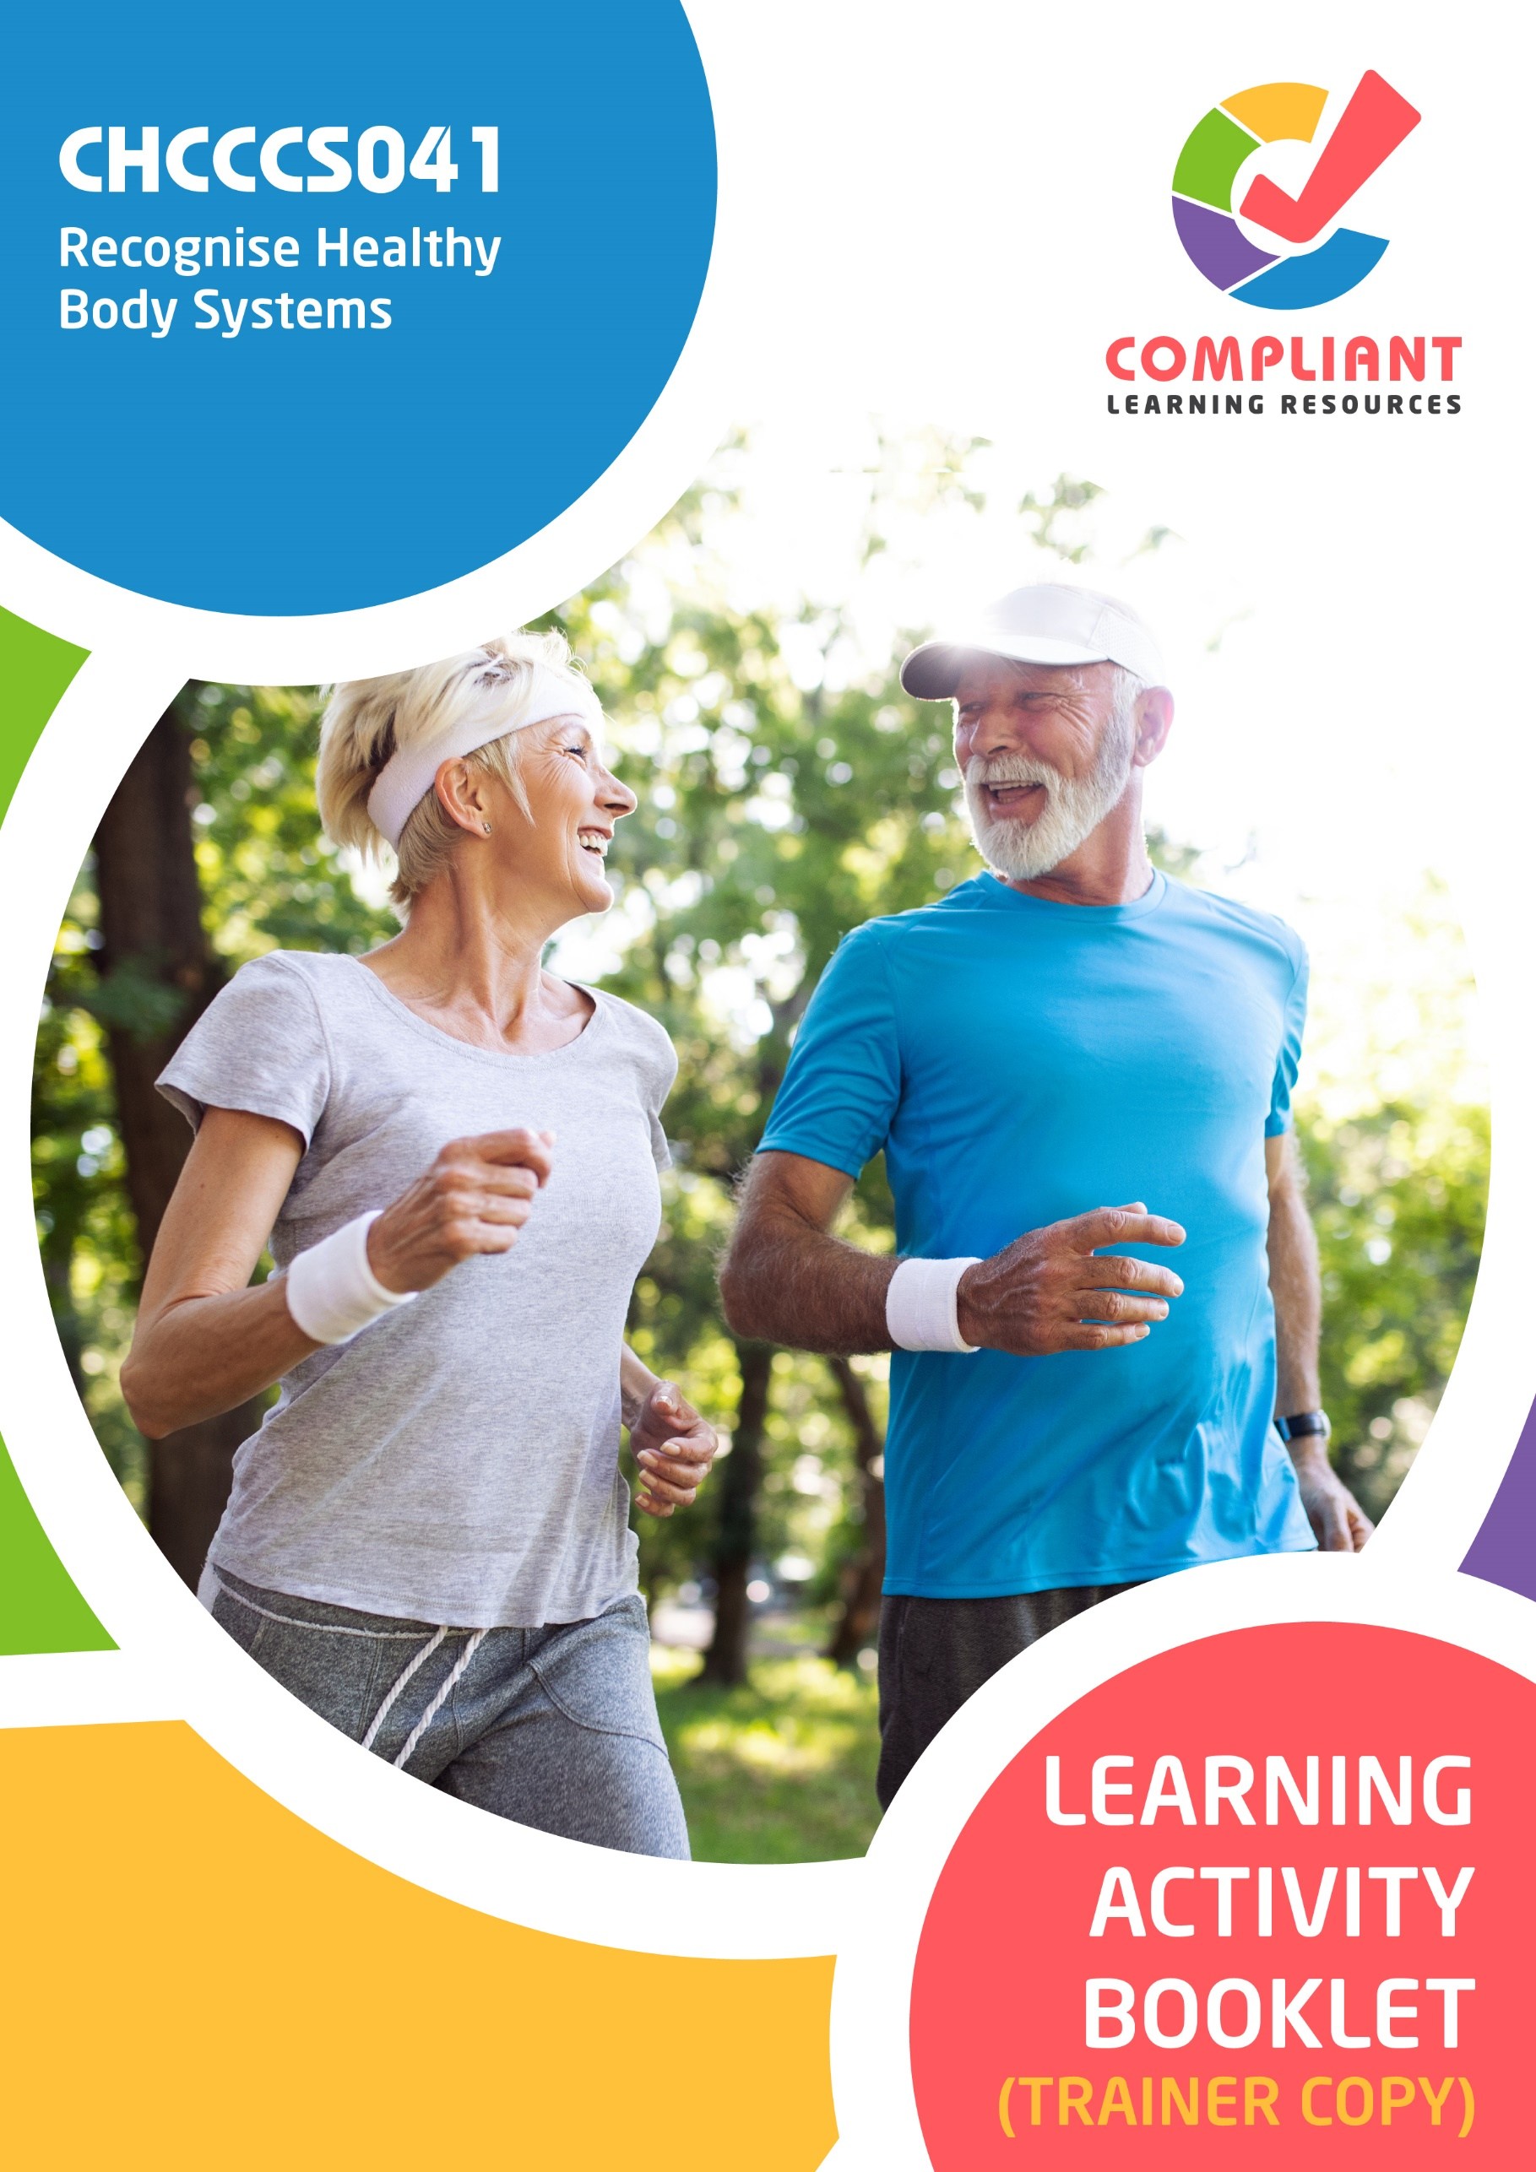

**Copyright**

This document was developed by Compliant Learning Resources.

© 2023 Compliant Learning Resources.

All rights reserved.

No part of this publication may be reproduced, stored in a retrieval system, or transmitted in any form or by any means, electronic, mechanical, photocopying, recording, or otherwise without the prior written permission of Compliant Learning Resources.

**Version Control & Document History**

|  |  |  |
| --- | --- | --- |
| **Date** | **Summary of Modifications** | **Version** |
| 13 January 2023 | Version 1.0 released for publishing | 1.0 |

# Table of Contents

Overview 4

Trainer Instructions 5

Learner Instructions 6

Learner Information 6

Trainer Information 6

Resources Required 7

Work Health and Safety 7

Reasonable Adjustment 8

Contextualisation 9

Formative Activities 10

I. Work with Information About the Human Body 10

Activity 1.1 10

Activity 1.2 11

Activity 1.3 12

Activity 1.4 15

II. Recognise and Promote Ways to Support Healthy Functioning of the Body 16

Activity 2.1 16

Activity 2.2 17

Activity 2.3 19

# Overview

**CHCCCS041 - Recognise healthy body systems (Release 1)**

This unit describes the performance outcomes, skills and knowledge required to work with basic information about healthy body systems and the impacts of ageing and disability.

This unit applies to workers across a range of community services contexts.

The skills in this unit must be applied in accordance with Commonwealth and State/Territory legislation, Australian standards and industry codes of practice.

No occupational licensing, certification or specific legislative requirements apply to this unit at the time of publication.

**A complete copy of the above unit of competency can be downloaded from the TGA website:**

<https://training.gov.au/Training/Details/CHCCCS041>

# Trainer Instructions

This Learning Activity Booklet contains formative activities that learners will complete in the classroom or a similar environment.

These formative activities include knowledge questions to test learners’ underpinning generic knowledge and practical activities to test their skills relevant to the unit/s of competency.

These formative assessments are used by trainers to complement both the learning and training processes, and to evaluate how learners are progressing throughout these processes.

**IMPORTANT:**

**The completion of the formative assessments and learning activities included in this workbook DOES NOT lead to a Qualification or a Statement of Attainment (SOA).**

Reasonable adjustment applies here, and while the majority of learners will complete this assessment as a written assessment, verbal assessment may be an option for those who need it. The assessor must use the marking guide as the principal marking tool unless a reasonable adjustment is demonstrated.

The Learning Activity Booklet (Trainer Copy) provides model answers to all the questions, setting out which key responses must be included as well as indicating where flexibility is acceptable.

The number of responses required is specified in each assessment task to avoid ambiguity. In these cases, the model answer will provide a list of possible answers. For instance, if a question requires the learner to list three examples, then their response must include three of the items listed in the model answer.

# Learner Instructions

This Learning Activity Booklet contains formative activities that learners will complete in the classroom or a similar environment.

These formative activities include knowledge questions to test your underpinning generic knowledge and practical activities to test your skills relevant to the unit/s of competency.

These formative assessments are used by your trainer to complement both the learning and training processes, and to evaluate how you are progressing throughout these processes.

You may reference your Learner Guide and other learning materials to complete the activities included in this workbook.

**IMPORTANT:**

**The completion of the formative assessments and learning activities included in this workbook DOES NOT lead to a Qualification or a Statement of Attainment (SOA).**

## Learner Information

|  |  |
| --- | --- |
| Learner name |  |
| Phone |  |
| Email |  |

## Trainer Information

|  |  |
| --- | --- |
| Trainer name |  |
| RTO name |  |
| RTO phone |  |
| RTO email |  |

# Resources Required

Resources needed to complete activities included in this workbook include:

* Computer with Internet, email access, and a working web browser
* Installed software: MS Word, Adobe Acrobat Reader
* Learner guide

# Work Health and Safety

Both the trainers and learners have duty of care in ensuring that the learning environment is free from hazards that may pose risks to their health and safety.

According to WHS legislation, trainers and learners must take reasonable care while undertaking the activities included in this workbook in the learning environment.

# Reasonable Adjustment

‘Reasonable adjustment’ in VET is the term applied to modifying the learning environment or making changes to the training delivered to assist a learner with a disability. A reasonable adjustment can be as simple as changing classrooms to be closer to amenities or installing a particular type of software on a computer for a person with vision impairment.

**Why make a reasonable adjustment?**

We make reasonable adjustments in VET to make sure that learners with disabilities have:

* The same learning opportunities as learners without disabilities, and
* The same opportunity to perform and complete assessments as those without disabilities.

**Reasonable adjustment applied to participation in teaching, learning, and assessment activities can include:**

* Customising resources and assessment activities within the training package or accredited course
* Modifying the presentation medium
* Learner support
* Use of assistive/adaptive technologies
* Making information accessible both before enrolment and during the course
* Monitoring the adjustments to ensure learner needs continue to be met

**Assistive/Adaptive Technologies**

Assistive/adaptive technology means ‘software or hardware that has been specifically designed to assist people with disabilities in carrying out daily activities’ (World Wide Web Consortium - W3C). It includes screen readers, magnifiers, voice recognition software, alternative keyboards, devices for grasping, visual alert systems, and digital note-takers.

*(Adapted Reasonable Adjustment in teaching, learning and assessment for learners with a disability - November 2010 - Prepared by - Queensland VET Development Centre)*

**IMPORTANT:**

**Reasonable adjustment made for collecting learner assessment evidence must not impact the standard expected by the workplace, as expressed by the relevant unit/s of competency. For example, if the assessment were gathering evidence of the learner’s competency in writing, allowing the learner to complete the assessment verbally would not be a valid assessment method. The method of assessment used by any reasonable adjustment must still meet the competency requirements.**

# Contextualisation

Contextualisation is the process of modifying assessment tools to make learning more meaningful for your students and their employers.

Compliant Learning Resources highly recommends that your RTO contextualise the assessment tools before using them.

You must contextualise the assessment tools to suit:

* Your student’s needs
* Your RTO’s training and assessment processes
* The work and industry context in which you operate

**Contextualising for your state/territory**

The contents of this assessment tool are not written for a specific state/territory unless stated otherwise. Where the assessment tool refers to legislation and other industry requirements, which may vary across states/territories, model answers are based on one state/territory.

Should your RTO intend to use this assessment tool for learners from your state/territory, Compliant Learning Resources recommends you to:

* Access and review the legislation and industry requirements applicable in your state/territory.
* Update assessments and benchmark answers to reflect the legislation and industry requirements applicable in your state/territory.

When you are contextualising assessment tools, you must ensure that you retain the integrity of the assessment and the outcomes of the unit of competency.

**A comprehensive guide to contextualising your assessment tools for your RTO can be accessed through this link:**

<https://compliantlearningresources.com.au/blog/simple-guide-to-contextualising-rto-training-resources-and-assessment-tools/>

# Formative Activities

## I. Work With Information About the Human Body

### Activity 1.1

|  |  |
| --- | --- |
| **True or False**  Review the statements below about different body systems. Indicate whether each statement is True or False.  Tick the box that corresponds to your answer. | |
|  | |
| *Mapping: CHCCCS041 PC1.1 (p), KE1.1 (p), KE1.2 (p), KE1.3 (p), KE1.9 (p), KE1.10 (p), KE1.12 (p), KE1.13 (p)*  *Learner guide references:*   * *CHCCCS041 Learner Guide, Chapter 1, Subchapter 1.1, Section 1.1.1* * *CHCCCS041 Learner Guide, Chapter 1, Subchapter 1.1, Section 1.1.2* * *CHCCCS041 Learner Guide, Chapter 1, Subchapter 1.1, Section 1.1.3* * *CHCCCS041 Learner Guide, Chapter 1, Subchapter 1.1, Section 1.1.7* * *CHCCCS041 Learner Guide, Chapter 1, Subchapter 1.1, Section 1.1.8* * *CHCCCS041 Learner Guide, Chapter 1, Subchapter 1.1, Section 1.1.11* * *CHCCCS041 Learner Guide, Chapter 1, Subchapter 1.1, Section 1.1.12* | |
| TRUE  FALSE | 1. The cardiovascular system is responsible for transporting oxygen, blood cells, water and nutrients around the body. |
| TRUE  FALSE | 1. The respiratory system is responsible for giving structure and providing the body with the right amount of blood cells. It also facilitates movement and locomotion. |
| TRUE  FALSE | 1. The reproductive system serves as defence against bacteria, pollution, and harmful UV rays from the sun. |
| TRUE  FALSE | 1. The spinal cord links the brain and the peripheral nervous system (PNS). |
| TRUE  FALSE | 1. The nose gives the body a sense of equilibrium or the sense that gives humans an idea about the position of the body. |

### Activity 1.2

|  |  |  |  |
| --- | --- | --- | --- |
| **Matching Type**  Shown below is the diagram of the parts of the digestive system.  Identify each numbered part by selecting your answer from the drop-down list below. | | | |
|  | | | |
|  | | | |
| *Mapping: CHCCCS041 PC1.1 (p), KE1.6 (p)*  *Learner guide reference: CHCCCS041 Learner Guide, Chapter 1, Subchapter 1.1, Section 1.1.5* | | | |
| **1** | Choose an item. Mouth | **6** | Choose an item. Stomach |
| **2** | Choose an item. Liver | **7** | Choose an item. Pancreas |
| **3** | Choose an item. Gall bladder | **8** | Choose an item. Duodenum |
| **4** | Choose an item. Large intestine | **9** | Choose an item. Small intestine |
| **5** | Choose an item. Oesophagus | **10** | Choose an item. Anus |

### Activity 1.3

|  |
| --- |
| **SCENARIO**  Friday, 11 March 20xx, 8:00 AM  *Where 20xx refers to the current year*  Madge has been in your care since she arrived at the centre two years ago. However, you have been away on holiday for the last two months, so another support worker had to be assigned to care for Madge.  On your first day back, as you and another individual support worker were about to hoist her from the bed and onto her wheelchair, you noticed that Madge had sore, purple discoloured and painful spots about 8cm across on both her shoulders and a smaller one about 3cm across on the backside of her head.  When she was on her side, you saw some bleeding through her pants and on the bedsheets from the upper part of her buttocks. It appears it has not been checked for at least a day or two. Her bed sheets were stained and smelled of faeces and urine. She looked in pain. You asked her if you could check what was causing her pain. You found that she had an open wound about 2cm across, and the skin surrounding it was very red and discoloured. Madge cringed in pain as you gently assessed the condition of her skin.  You later found out that she has not been out of her bed in two days. You asked her why she has not gone out of her bed, and she told you that she is just feeling too tired lately and going out just takes too much effort. She asked you if she could just stay in bed and rest today. You noticed that she seems withdrawn. You also noticed that she has lost a lot of weight since the last time you saw her about two months ago.  Madge asked you if you could get medication to help her with the pain. She started feeling pain in her buttocks and both shoulders two days ago but did not tell anyone until you were back from your leave. When you asked her why she did not tell anyone about it, she said she did not want to bother the nurse. This made you worry about Madge and asked her if there was anything else that was bothering her. You found out that she has not had any bowel movement in two days, and urinating has started to become painful for her.  She asked if you could clean her wounds and give her pain medication. You explained to her that although you would love to help her, you are not qualified to perform those procedures on clients. You checked her care plan and found that her nurse’s name is Olivia. You explained to Madge that registered nurse Olivia would be the best person to clean her wounds and help her manage her pain with medication as prescribed by her doctor.  Madge appeared nervous and anxious when you mentioned the nurse’s name. She hesitantly tells you that the pain is gone, and she feels fine. She tells you she does not need the pain medication anymore. |

|  |
| --- |
| Below is a Progress Notes template. Complete the template below by:   1. Identifying the date and time 2. Identifying three indicators of change with the client's condition 3. Providing action items on what needs to be done for each indicator identified |
|  |
| *Mapping: CHCCCS041 PC1.2 (p), KE3.6 (p), KE4.11 (p), KE11.1 (p)*  *Learner guide reference:*   * *CHCCCS041 Learner Guide, Chapter 1, Subchapter 1.2, Section 1.2.1* * *CHCCCS041 Learner Guide, Chapter 1, Subchapter 1.2, Section 1.2.2*   **Marking guide**  The learner must fill out the Progress Notes by:   1. Identifying the date and time   For a satisfactory performance, their response must be consistent with the model answers below.   1. Identifying three indicators of change with the client's condition   For a satisfactory performance, their response must be:   * Consistent with the scenario provided * Indicators of change in the client's physical, psychological or mental health condition  1. Providing action items on what needs to be done for each indicator identified   For a satisfactory performance, their response must be:   * Consistent with the indicators of change that they provided * Actions that support workers must do to attend to the indicators of change identified   Benchmark answers are provided below for the trainer’s reference in evaluating the learner’s performance. |

|  |  |  |
| --- | --- | --- |
| **Date** | **Status** | **Action point** |
| Friday, 11 March 20xx, 8:00 AM | Madge had sore, purple discoloured and painful spots about 8cm across on both her shoulders and a smaller one about 3cm across on the backside of her head. | Reach out to the registered nurse, Olivia, to clean Madge’s wounds and help her manage her pain with medication as prescribed by her doctor. |
| When she was on her side, she had some bleeding through her pants and on the bedsheets from the upper part of her buttocks. Her bed sheets were also stained and smelled of faeces and urine. | Help Madge clean herself and her bed. Provide new and clean clothes and bedsheets for Madge to avoid further contamination and infection on her existing wounds. |
| There is an open wound about 2cm across, and the skin surrounding it was very red and discoloured. She did not tell anyone about it because she does “not want to bother the nurse”. | Consult your supervisor regarding Madge’s behaviour towards her wariness about calling in the nurse for help. |

*Add rows as necessary*

### Activity 1.4

|  |
| --- |
| List three ways on how health-related terminologies and abbreviations relevant to body systems can help you in performing your work role. |
|  |
| *Mapping: CHCCCS041 PC1.1 (p)*  Learner guide reference: CHCCCS041 Learner Guide, Chapter 1, Subchapter 1.1  **Marking guide**  The learner must list three ways on how health-related terminologies and abbreviations relevant to body systems can help them in performing their work role.  For a satisfactory performance, although the wording may slightly vary, their response must:   * Pertain to a work role of a support worker * Be relevant to tasks needing interpretation of health-related terminologies and abbreviations * Be relevant to social and health services offered to clients who are ageing and/or with a disability   Model answers are provided below for the assessor’s reference. |
| Interpreting medical advice to the client given by the doctor |
| Recognising changes in the physical, psychological and mental condition of the client |
| Reporting indicators of body system issues |

## II. Recognise and Promote Ways to Support Healthy Functioning of the Body

### Activity 2.1

|  |  |
| --- | --- |
| **Matching Type**  Listed below are different factors that contribute to the overall health of a person’s body:   1. Nutrition 2. Hydration 3. Skin integrity 4. Movement 5. Social interaction   Match each factor to the resources below that are used to review the client's medical history and clinical status. Write the letter that corresponds to your answer in the space provided. | |
|  | |
| *Mapping: CHCCCS041 PC2.1 (p), KE5.1 (p), KE5.2 (p), KE5.3 (p), KE5.4 (p), KE5.5 (p)*  *Learner guide reference: CHCCCS041 Learner Guide, Chapter 2, Subchapter 2.1* | |
| Resources to Review | |
| d | 1. Physical therapy assessment documentation, medical history (to check for previous injuries) |
| a | 1. Nutrition assessments, food diary, etc. |
| b | 1. Vital signs, fluid balance chart, daily weight chart, fluid prescription chart, surgical documentation (if the client is post-op) |
| c | 1. Pressure Ulcers Clinical Data Collection Form or other similar documents |
| e | 1. Psychological reports, geriatric functional assessment documentation, etc. |

### Activity 2.2

|  |  |  |  |  |  |  |  |
| --- | --- | --- | --- | --- | --- | --- | --- |
| **Matching Type**  Identify the allied health professional being described in each statement below.   |  | | --- | | **Multidisciplinary Health Professionals** | | Physical therapists | | Speech pathologists | | Respiratory therapists | | Clinical nutritionists | | Pharmacists | | |
|  | |
| *Mapping: CHCCCS041 PC2.3 (p), KE6.0 (p)*  *Learner guide reference: CHCCCS041 Learner Guide, Chapter 2, Subchapter 2.3* | |
| Description | |
| Physical therapists | 1. These are professionals who help improve or restore physical functioning, such as strength or movement of the client. |
| Clinical nutritionists | 1. These are professionals who work with individual clients to ensure they get proper nutrition based on their medical condition. |
| Pharmacists | 1. These are professionals who provide advice on how to use medicine safely. They also offer a range of services, including healthcare advice, vaccinations, self-care and lifestyle assessments and provide medical certificates. |

|  |  |
| --- | --- |
| Description | |
| Speech pathologists | 1. These are professionals who help improve or restore speech of clients who have had illnesses that affected their speech. |
| Respiratory therapists | 1. These are professionals who administer medication, set up and monitor life support equipment such as ventilators, and teach patients how to manage chronic lung disorders. |

### Activity 2.3

|  |
| --- |
| List down four ways to avoid infecting elderly and disabled clients. |
|  |
| *Mapping: CHCCCS041 PC2.2 (p), KE2.2 (p)*  *Learner guide reference: CHCCCS041 Learner Guide, Chapter 2, Subchapter 2.2, Section 2.2.2*  **Marking guide**  The learner must list down four ways to avoid infecting elderly and disabled clients.  Responses may vary. For a satisfactory performance, their response must be courses of action that support workers must do to prevent spreading infection to elderly and disabled clients.  Below are examples of satisfactory responses provided for the assessor's reference. |
| Stay away from the client when sick |
| Wash hands at regular intervals. |
| Clean thoroughly |
| Wear protective equipment |

End of Document